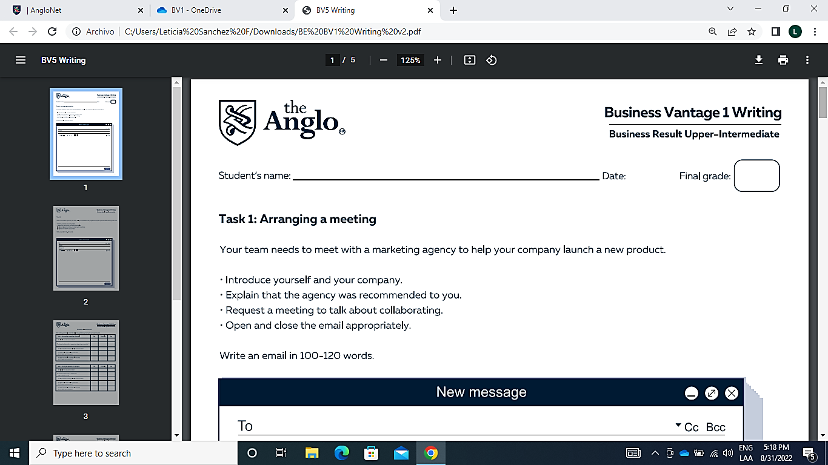

Jorge Ramírez Chávez

|  |
| --- |
| Dear All  My name is Jorge Ramírez Chavez, I’m a software engineer for KTSA an IT consulting company. I was given your information by one of my teammates, Bryan Ubaldo. He recommended your marketing agency as we need to start a campaign to attract more clients to our company. I understand that you worked with him on another company and the campaign was successful, isn’t it?  If you are interested in discussing this further so we can collaborate, please answer to this email or feel free to call me to my phone so we can meet this week or next week, whatever’s best for you.  Best Regards. |

|  |
| --- |
| Hi Leticia  I’m emailing you to give an update on progress for the production servers migration that I’ve been working on. Up to now I have migrated 15 of 20 application servers to the cloud and the migration is running as smoothly as we’d hoped, if we stay the course, we’ll finish the migration by the end of the month, but the cloud spending on this project is going out of control, we’re spending so much money on bills that it’s difficult to stay within budget.  I’ll be working on the 5 servers that are missing and keep you informed on the progress. I’m convinced that we can finish on time.  Best wishes  Jorge Ramirez Chavez |